MACHINE LEARNING

In Q1 to Q11, only one option is correct, choose the correct option:

1. Which of the following methods do we use to find the best fit line for data in Linear Regression?

A) Least Square Error B) Maximum Likelihood
C) Logarithmic Loss D) Both A and B

Ans: A) Least Square Error

2. Which of the following statement is true about outliers in linear regression?

A) Linear regression is sensitive to outliers
B) linear regression is not sensitive to outliers
C) Can’t say
D) none of these

Ans: A) Linear regression is sensitive to outliers

3. A line falls from left to right if a slope is ______?

A) Positive B) Negative
C) Zero D) Undefined

Ans: B) Negative

4. Which of the following will have symmetric relation between dependent variable and independent variable?

A) Regression B) Correlation
C) Both of them D) None of these

Ans: B) Correlation

5. Which of the following is the reason for over fitting condition?

A) High bias and high variance B) Low bias and low variance
C) Low bias and high variance D) none of these

Ans: C) Low bias and high variance

6. If output involves label then that model is called as:

A) Descriptive model B) Predictive model
C) Reinforcement learning D) All of the above

Ans: B) Predictive model

7. Lasso and Ridge regression techniques belong to _________?

A) Cross validation B) Removing outliers
C) SMOTE D) Regularization

Ans: D) Regularization

8. To overcome with imbalance dataset which technique can be used?

A) Cross validation B) Regularization
C) Kernel D) SMOTE

Ans: A) Cross validation

9. The AUC Receiver Operator Characteristic (AUCROC) curve is an evaluation metric for binary classification problems. It uses _____ to make graph?

A) TPR and FPR B) Sensitivity and precision
C) Sensitivity and Specificity D) Recall and precision

Ans: A) TPR and FPR

10. In AUC Receiver Operator Characteristic (AUCROC) curve for the better model area under the curve should be less.

A) True B) False

Ans: B) False

11. Pick the feature extraction from below:

A) Construction bag of words from a email
B) Apply PCA to project high dimensional data
C) Removing stop words
D) Forward selection

Ans: B) Apply PCA to project high dimensional data

In Q12, more than one options are correct, choose all the correct options:

12. Which of the following is true about Normal Equation used to compute the coefficient of the Linear Regression?

A) We don’t have to choose the learning rate.
B) It becomes slow when number of features is very large.
C) We need to iterate.
D) It does not make use of dependent variable.

Ans: A, B, C

Q13 and Q15 are subjective answer type questions, Answer them briefly.

13. Explain the term regularization?

Ans: Regularization is a technique used in regression to reduce the complexity of the model and to shrink the coefficients of the independent features. Regularization helps the model from overfitting by adding extra information to it.
Sometimes the machine learning model performs well with the training data, but does not perform well with the test data. It means the model is not able to predict the output when deals with unseen data by introducing noise in the output, and hence the model is called over-fitted. This problem can be dealt with the help of a regularization technique.
This technique can be used in such a way that it will allow to maintain all variables or features in the model by reducing the magnitude of the variables. Hence, it maintains accuracy as well as a generalization of the model.
It mainly regularizes or reduces the coefficient of features towards zero. In simple words, “In regularization technique, we reduce the magnitude of the features by keeping the same number of features”.

14. Which particular algorithms are used for regularization?
Ans: The algorithms used for regularization are:
- Ridge Regression
- LASSO (Least Absolute Shrinkage and Selection Operator) Regression
- Elastic-Net Regression

The working of all these algorithms is quite similar to that of Linear Regression, it’s just the loss function that keeps on changing!

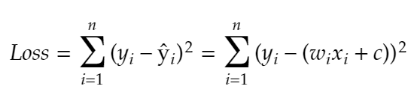
- Ridge Regression
Ridge regression is a method for analyzing data that suffer from multi-collinearity.

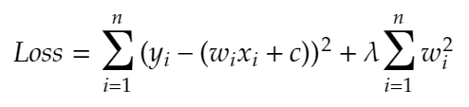

Loss Function for Ridge Regression
Ridge regression adds a penalty (L2 penalty) to the loss function that is equivalent to the square of the magnitude of the coefficients.
The regularization parameter (λ) regularizes the coefficients such that if the coefficients take large values, the loss function is penalized.
- λ → 0, the penalty term has no eﬀect, and the estimates produced by ridge regression will be equal to least-squares i.e. the loss function resembles the loss function of the Linear Regression algorithm. Hence, a lower value of λ will resemble a model close to the Linear regression model.
- λ → ∞, the impact of the shrinkage penalty grows, and the ridge regression coeﬃcient estimates will approach zero (coefficients are close to zero, but not zero).
Note: Ridge regression is also known as the L2 Regularization.
To sum up, Ridge regression shrinks the coefficients as it helps to reduce the model complexity and multi-collinearity.

- LASSO Regression

LASSO is a regression analysis method that performs both feature selection and regularization in order to enhance the prediction accuracy of the model.

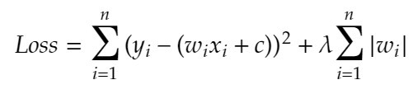

Loss Function for LASSO Regression
LASSO regression adds a penalty (L1 penalty) to the loss function that is equivalent to the magnitude of the coefficients.
In LASSO regression, the penalty has the eﬀect of forcing some of the coeﬃcient estimates to be exactly equal to zero when the regularization parameter λ is suﬃciently large.
Note: LASSO regression is also known as the L1 Regularization (L1 penalty).
To sum up, LASSO regression converts coefficients of less important features to zero, which indeed helps in feature selection, and it shrinks the coefficients of remaining features to reduce the model complexity, hence avoiding overfitting.

- Elastic-Net Regression
Elastic-Net is a regularized regression method that linearly combines the L1 and L2 penalties of the LASSO and Ridge methods respectively.

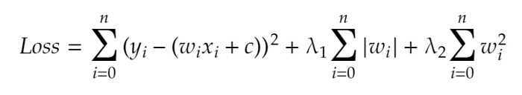

Loss Function for Elastic-Net Regression

15. Explain the term error present in linear regression equation?

Ans: When working with linear regression, our main goal is to find the best fit line that means the error between predicted values and actual values should be minimized. The best fit line will have the least error.
The different values for weights or the coefficient of lines (a₀, a₁) gives a different line of regression, so we need to calculate the best values for a₀ and a₁ to find the best fit line, so to calculate this we use cost function.
Cost function:
- The different values for weights or coefficient of lines (a₀, a₁) gives the different line of regression, and the cost function is used to estimate the values of the coefficient for the best fit line.
- Cost function optimizes the regression coefficients or weights. It measures how a linear regression model is performing.
- We can use the cost function to find the accuracy of the mapping function, which maps the input variable to the output variable. This mapping function is also known as Hypothesis function.
For Linear Regression, we use the Mean Squared Error (MSE) cost function, which is the average of squared error occurred between the predicted values and actual values. It can be written as:
For the above linear equation, MSE can be calculated as:
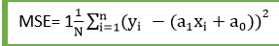
Where,
N=Total number of observation
Yi = Actual value
(a1xi+a0)= Predicted value.

Residuals: The distance between the actual value and predicted values is called residual. If the observed points are far from the regression line, then the residual will be high, and so cost function will high. If the scatter points are close to the regression line, then the residual will be small and hence the cost function.

Gradient Descent:
- Gradient descent is used to minimize the MSE by calculating the gradient of the cost function.
- A regression model uses gradient descent to update the coefficients of the line by reducing the cost function.
- It is done by a random selection of values of coefficient and then iteratively update the values to reach the minimum cost function.

